2025上海国际学术会议 - 临床ADMET的预测
2025 Shanghai International Workshop: the Predictive ADMET
- Advancing Drug Interaction Prediction, Pharmacogenomics and Special Populations through PBPK Modeling and Clearance Concepts

2025年6月27日（周五）- 6月28日（周六）
上海科技大学生命科学与技术学院会议厅，上海浦东新区华夏中路393号



学术指导单位

中国生物医药产业链创新转化联合体药代动力学专委会（CBIITA-SSX）

主办单位

- 上海科技大学iHuman 研究所
- 瑞德肝脏疾病研究（上海）有限公司（RILD）
- 江苏万略医药科技有限公司 (Value)
- 上海益诺思生物技术股份有限公司 (InnoStar)
- 康龙化成（北京 ) 新药技术股份有限公司(Pharmaron)
- BioIVT，LLC.（美国）
- GenoMembrane Co., Ltd.（日本）
- Hypha Discovery Limited （英国）

组委会主席

- 杉山雄一博士，上海科技大学iHuman研究所，特聘教授
- 胡卓汉博士，瑞德肝脏疾病研究上海有限公司, CEO

会议简介

上海首届《临床ADMET的预测（SPADMET）国际学术会议》邀请了在学术、工业和药监部门的药理毒理的资深科研工作者，旨在共同探讨通过体外研究及PBPK建模，研判药物清除及相应的药理毒理概念。为期两天的学术交流将交流分享PBPK支持新药开发和IND/NDA注册的实际见解。参与者将获得预测药物行为、评估药物相互作用（DDIs）以及评价药代动力学/药效学（PK/PD）关系的专业知识。主题包括通过体外-体内推断（IVIVE）来最小化临床试验、优化给药策略以及了解特殊人群和器官损伤患者的药物反应。
参会注册：扫描下方二维码
参会注册费（包括午餐/茶歇）：500元/人。
在读学生、博士后研究员：300元/人。


参展注册：
参展注册费，标准展位（2米宽）：10000元/展位。

注册联系人：
陶晓佳：邮箱taoxj@rild-biotech.com， 电话 15961775103（微信同号）
严婷婷：邮箱yantt@rild-biotech.com， 电话 13341792601（微信同号）

会务发票：
开票内容：会务费
发票类型：电子发票（专票或普票均可）
开票时间：2025年7月
开票信息：2025年7月1日在会议微信群提供微信二维码，扫码提交开票信息

会务费收款信息：
付款方式1：银行转账
公司名称：瑞德肝脏疾病研究（上海）有限公司
开户银行：建设银行上海张江分行
账号：3100 1523 2110 5600 2186
付款方式2：支付宝（付款需添加备注，注明付款人信息）
 | 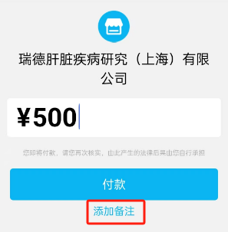
会议议程PROGRAM
June 27, Friday. 6月27日,周五
9:00-9:30 | Opening Ceremony  Session Chair  Dr. Zhuohan Hu  CEO, RILD, China | 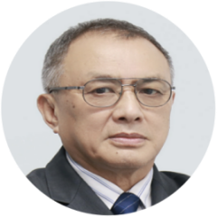
9:00-9:30 | Host Welcome  Dr. Zhijie Liu  Professor, iHuman Institute, ShanghaiTech Univ. ,China | 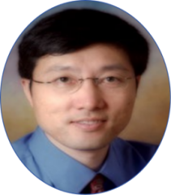
9:00-9:30 | Opening Remark  Dr. Kaixian Chen  Professor, Shanghai Institute of Medicar Meteria  Academician, Chinese Academy of Science, China  Chairman, CBIITA, China | 
9:00-9:30 | Opening Remark  Dr. Jasminder Sahi  Senior Director, Sanofi, USA  Chair of Membership, ISSX | 
9:30-10:15 | Keynote Lecture  Session Chair  Dr. Sylvia Zhao  VP, CICoR ,China | 
9:30-10:15 | Advancing Drug Interaction Prediction, Pharmacogenomics and Special Populations through PBPK Modeling and Clearance Concepts  Dr. Yuichi Sugiyama  Professor, iHuman Institute, ShanghaiTech Univ., China | 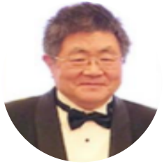
Symposium 1 Emerging sciences in drug discovery and development: Structure biology, Chemical biology and CGNM method  Session Chair  Dr. Mandy Xu  Senior VP, Pharmaron, China |  | 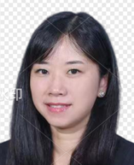
10:15-10:50 | Structural Biology in Drug Development: From Protein Structures to Novel Therapies  Dr. Tian Hua  Associate Professor, iHuman Institute, ShanghaiTech Univ, China | 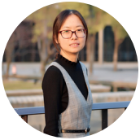
10:50-11:25 | GPCR-Targeted Drug Discovery for the Treatment of Mental Disorders  Dr. Jianjun Cheng  Associate Professor, iHuman Institute, ShanghaiTech Univ, China | 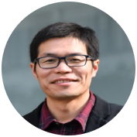
11:25-12:00 | Cluster Gauss–Newton method : An algorithm for finding multiple approximate minimisers of nonlinear least squares problems with applications to parameter estimation(Top-down/Middle- out) of PBPK models  Dr. Yasunori Aoki  AstraZeneca, Sweden | 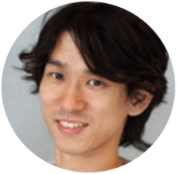
12:00-13:00 | Lunch Break
Symposium 2.1 DDI prediction, PGs, endogenous biomarker  Session Chair  Dr. Genfu Chen  Exec. Director, DMPK, Wuxi Apptec, China |  | 
13:00-13:40 | [Keynote Lecture] Recent Developments in Endogenous Biomarkers for Transporter-Mediated Drug-Drug Interactions  Dr. Hiroyuki Kusuhara  Professor, Univ. of Tokyo, Japan | 
13:40-14:10 | Understanding the effect of CYP3A inhibitors on Venglustat pharmacokinetics with a drug-drug interaction study and PBPK modelling  Dr. Jasminder Sahi,  Senior Director, Sanofi, USA
14:10-14:40 | Assessing the relative contribution of CYP3A-and P-gp-mediated pathways to the overall disposition and drug-drug interaction of dabigatran etexilate using a comprehensive mechanistic physiological-based pharmacokinetic model  Dr. Thomayant Prueksaritanont  Professor, Chulalongkorn Univ. Thailand | 
14:40-14:55 | Cafe Break
Symposium 2.2 DDI prediction, PGs, endogenous biomarker  Session Chair  Dr. Dongyang Liu  Professor, Beijing Univ. 3rd Hospital, China |  | 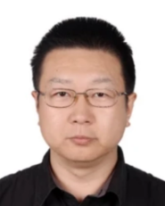
14:55-15:25 | PBPK modeling for complex DDI caused by clopidogrel and its metabolites: Stepwise model verification using probe drugs for CYP2C8 and OATP1B  Dr. Soo-Jin Kim  SPMED , Korea | 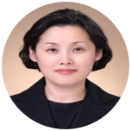
15:25-15:55 | PBPK modeling of time dependent inhibition of OATP1B mediated hepatic uptake of pitavastatin taking into account the trans-inhibition mechanism  Dr. Yuichi Sugiyama  Professor, iHuman Institute, ShanghaiTech Univ., China
15:55-17:00 | Panel Discussion
18:00 | Banquet
June 28, Saturday, 6月29日,周六
Symposium 3.1 Mechanism based modeling (PBPK)  Session Chair  Dr. Bingliang Ma  Professor, Shanghai Univ. of Chinese Medicine, China |  | 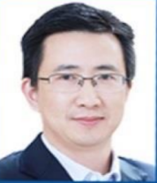
9:00-9:40 | [Keynote Lecture] Pharmacokinetics has opened the door of modeling and simulation in pharmaceutical sciences  Dr. Akihiro Hisaka  PMDA, Japan | 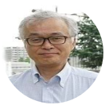
9:40-10:10 | Integrating Non-Compartmental Analysis and PBPK Modeling: How to Understand Nonlinear Pharmacokinetic Mechanisms and Approximate Bioavailability Under Nonlinear Conditions  Dr.Toshiaki Tsuchitani  Assistant Professor, Keio University, Japan | 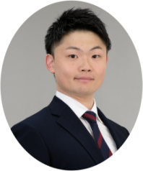
10:10-10:40 | Blood PK to Target: In Vivo Target Occupancy Prediction  Dr. Wooin Lee  Professor, Seoul National University, Korea | 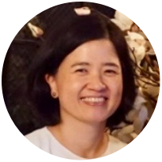
Symposium 3.2 Mechanism based modeling (PBPK)  Session Chair  Dr. Dafang Zhong  Professor, Shanghai Institute of Medica Metaria, China |  | 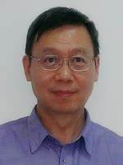
10:40-11:10 | Essential PBPK parameters revisited: Mean transit time, tissue partitioning, and clearance  Dr. Yoo-Seong Jeong  Professor, Seoul National Univ. Korea | 
11:10-11:40 | Translational human PK prediction of Fc-engineered monoclonal antibodies from cynomolgus monkey and human FcRn transgenic mice  Dr. Kenta Haraya  Chugai Pharma , Japan | 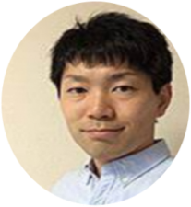
11:40-12:10 | Smart Choices, Better Predictions: A fit-for-purpose Approaches to Human Efficacious Dose  Dr. Yurong Lai  Gilead Sciences, USA | 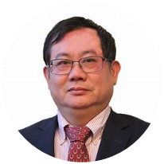
12:10-12:40 | Harnessing IVIVE-PBPK to Explore Local Gut vs. Systemic Bioequivalence Discordance in Health and Disease: A Case Study of Budesonide in Crohn’s Disease  Dr. Chunyan Han  Executive Director, Pharmaron, China | 
12:40-13:40 | Lunch Break
Symposium 4.1 In vitro In vivo extrapolation (IVIVE)  Session Chair  Dr. Zheming Gu  CEO, Value Pharma, China |  | 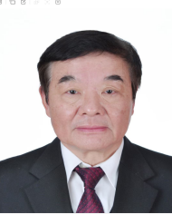
13:40-14:20 | (Keynote Lecture)Establishment of novel experimental systems with human crypt-derived intestinal cells for the quantitative prediction of drug intestinal absorption and toxicity  Dr. Kazuya Maeda,  Professor, Kitasato University, Japan | 
14:20-14:50 | Quantitative prediction of hepatic clearance and DDI risk using human liver chimeric mice  Dr. Tatsuhiko Tachibana  Chugai Pharma, Japan | 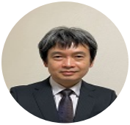
Symposium 4.2 In vitro In vivo extrapolation (IVIVE))  Session Chair  Dr. Yuchang Mao  Director, DMPK/TOX, Shanghai Hengrui Pharmaceutical,China |  | 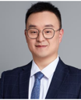
14:50-15:20 | Predictive ADMET in Clinical Pharmacokinetics & Drug Development  Dr. Yan Zhang  Nuvation Bio, USA | 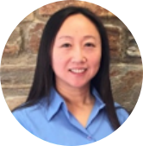
15:20-15:50 | Recent advancement of Albumin-mediated hepatic uptake: A cause for the poor IVIVE in the hepatic uptake clearance and non-linearity  Zhubing Hao  RILD, China | 
15:50-16:20 | OATP1B mediated hepatic uptake of drugs  Dr. Yifan Tu  Qilu, China | 
Symposium 5 prediction of Drug Induced Liver Injury (DILI)  Session Chair  Dr. Hua Li  Senior VP, Shanghai InnoStar Bio-tech Co., Ltd , China |  | 
16:20-17:00 | (Keynote Lecture) Understanding the Unpredictable: Mechanistic Insights into Idiosyncratic DILI for Informing Risk Prediction  Dr. Kousei Ito  Professor, Chiba University, Japan | 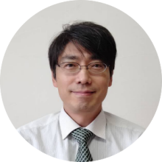
17:00-17:30 | Transporters and DILI  Dr. Sumito Ito  Executive Director, Genomembrane, Japan | 
17:30-18:00 | Panel Discussion/Close Remark  Session Chair  Dr. Yuichi Sugiyama  Professor, iHuman Institute, ShanghaiTech Univ., China

